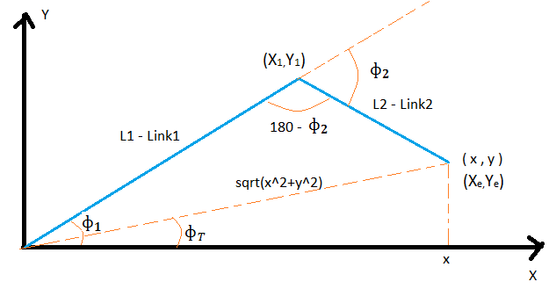

**Forward Kinematics of 4DOF Robot Arm:**

X1=L1sin ф1

Y1=L1cos ф1

Xe = Xend effector = L1 sin ф 1 + L2 sin (ф1+ф2)

Ye = Yend effector = L1 cos ф 1 + L2 cos (ф1+ф2)

Фe = Фend_effector = ф1+ ф2+ ф3

**Inverse Kinematics of 4DOF Robot Arm:**

By law of cosines, (here L1 = and L2 = )

This implies, $$ф_{1}=\cos^{-1}\left(\frac{x^{2}+y^{2}+ l_{1}^{2}- l_{2}^{2}}{2l_{1}\sqrt{x^{2}+y^{2}}}\right)+ \cos^{-1}\left(\frac{x}{\sqrt{x^{2}+y^{2}}}\right)$$

Calculating the angle between both the links 1 and 2,

$${cos⁡(180-ф}_{2})=\left(\frac{ l_{1}^{2}+ l_{2}^{2}-x^{2}-y^{2}}{2l_{1}l_{2}}\right)$$

$$-{cos⁡(ф}_{2})=\left(\frac{ l_{1}^{2}+ l_{2}^{2}-x^{2}-y^{2}}{2l_{1}l_{2}}\right)$$

$${⁡ф}_{2}=\cos^{-1}\left(\frac{ x^{2}+y^{2} {- l}_{1}^{2}- l_{2}^{2}}{2l_{1}l_{2}}\right)$$

Considering the angle of M3 (base rotation),

$${⁡ф}_{3}=\tan^{-1}\left(\frac{y}{x}\right)$$